C:\Users\mome1\AppData\Roaming\Microsoft\Word\Python notes:
Create new env
# new conda enviroment for each new project (exam)
#conda env list # to see all env in my computer and the one that is currently active
#conda create -n nameiwant python=3.10 pandas # to create new env
# conda env create -n dugga_python --file dugga_python_env.yml
#conda activate nameiwant
#conda list #to see list of what we instailed
#conda deactivate
conda install -c conda-forge biopython # install biopython
conda install pip # to allow pip installations later if needed)
conda remove -n nameiwant --all # to remove conda environment

built-in string methods

From Bio import SeqIO
r and w fast a and fast q files

Leacture 1 : if-statements
All whole numbers
Mathematical operations can be used on these:
+ for addition
- for subtraction
* for multiplication
** for power
/ for division
// for floor division
% for modulo
Comparison symbols:
== equals
>, < greater and less than
>=, <= greater/less or equal
!=, not equals (! means “not” in general, I would suggest the not keyword instead for readability)
Rounds down

Core string methods (some)

- .lower() and .upper() – change case
- .replace() – replace characters with other characters
- .split() and .rsplit() – split string into list
- .join() – join an iterable into a string with custom delimiter
- .count() – count character occurrences
- .startswith() & .endswith() – match beginning/end of string
- .strip() --Removes whitespace/newlines around string " hello\n".strip() → "hello"
- .transcribe() from Bio.Seq import Seq
- .reverse_complement().transcribe() - -from Bio.Seq import Seq
- .translate() -- from Bio.Seq import Seq DNA (or RNA) sequence into its corresponding amino acid sequence

- simple plotting (should work with matplotlib) (leacture 6)
exam notes
4 ways to plot
#using the pyplot submodule in the matplotlib library
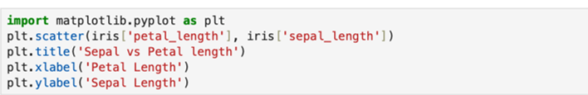

#Doing same plot using seaborn package also uses marplotlib
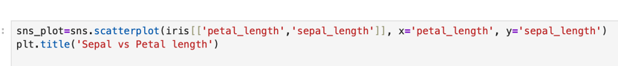

Plotly : not good for static plot, good to explor big data . can be shared as html . very havy to use
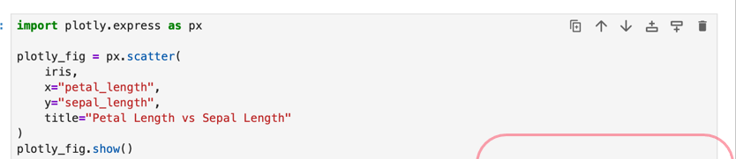
Plotnine : based on ggplot2. .show the image will pop on the screen
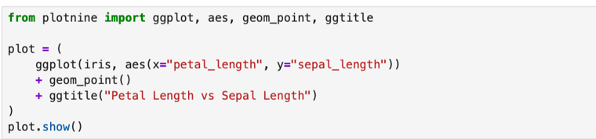

How to save a plot
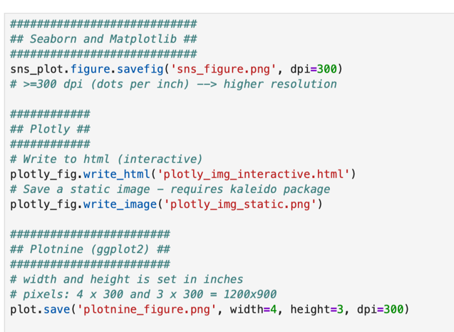
Klaleido package is not part of the duggs

